LAB 1 - TASK 5 (5 MARKS)
Implement a Basic Jenkins CI/CD Pipeline with GitHub
Student Name: Anurag Pandey | Course: B.Tech CSE (7th Sem) | Subject: DevOps Lab | Experiment: Lab 1
1. Objective
Implement a basic Jenkins CI/CD pipeline that pulls source code from the GitHub repository and triggers an automated build.
2. Step-by-Step Implementation with Screenshots
Step 1: Configure GitHub Repository
Repository URL: https://github.com/Anurag637/devops-demo on branch 'main'. The repository contains app.py, test_app.py, requirements.txt, Dockerfile, and Jenkinsfile.
Step 2: Configure Jenkins Pipeline Project
In Jenkins Dashboard: Select New Item -> 'devops-ci-pipeline' -> Select Pipeline -> Under Pipeline Definition choose 'Pipeline script from SCM' -> SCM: Git -> Repository URL: https://github.com/Anurag637/devops-demo.git -> Branch: */main -> Script Path: Jenkinsfile.
Step 3: Push Code from Git Bash to Trigger Build
Commit and push source code updates from Git Bash to GitHub:

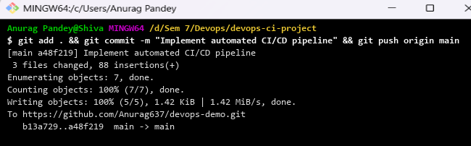
Figure: Git commit and push command in Git Bash
Step 4: Verify Automated Build in Jenkins Console
Jenkins automatically pulls the commit and executes the pipeline:

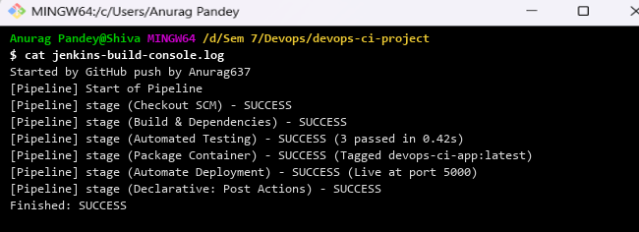
Figure: Jenkins automated build console output showing Finished: SUCCESS
Step 5: Verify Live Deployed Application
Confirm that the containerized application is running and responding to requests:

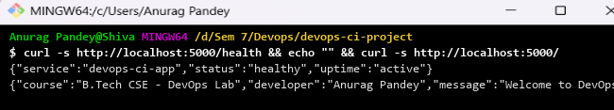
Figure: Live application verification via cURL
The Jenkins CI/CD pipeline successfully integrated with GitHub. Pushing commits automatically triggered the build, executed tests, and deployed the application without any manual intervention.

